2. SIGNAL PROPERTIES AND TRANSFORMATIONS

Experiment 2.4
Time Shifting and Time Reversal of Signals
Aim
Demonstrate time shift and reversal.
Apparatus Required
PC with MATLAB.
Program (MATLAB)
% Time Shifting and Time Reversal of Signals
clc;
clear;
close all;
% Time axis
t = -5:0.01:5;
% Original Signal
x = sin(2*pi*t);
% Time Shift (Delay by 2 seconds)
x_shift = sin(2*pi*(t-2));
% Time Reversal
x_reverse = sin(2*pi*(-t));
% Plotting
figure;
subplot(3,1,1);
plot(t,x,'LineWidth',2);
grid on;
title('Original Signal x(t)');
xlabel('Time (s)');
ylabel('Amplitude');
subplot(3,1,2);
plot(t,x_shift,'LineWidth',2);
grid on;
title('Time Shifted Signal x(t-2)');
xlabel('Time (s)');
ylabel('Amplitude');
subplot(3,1,3);
plot(t,x_reverse,'LineWidth',2);
grid on;
title('Time Reversed Signal x(-t)');
xlabel('Time (s)');
ylabel('Amplitude');
Output Generated Graph
Original, shifted, and reversed signals.
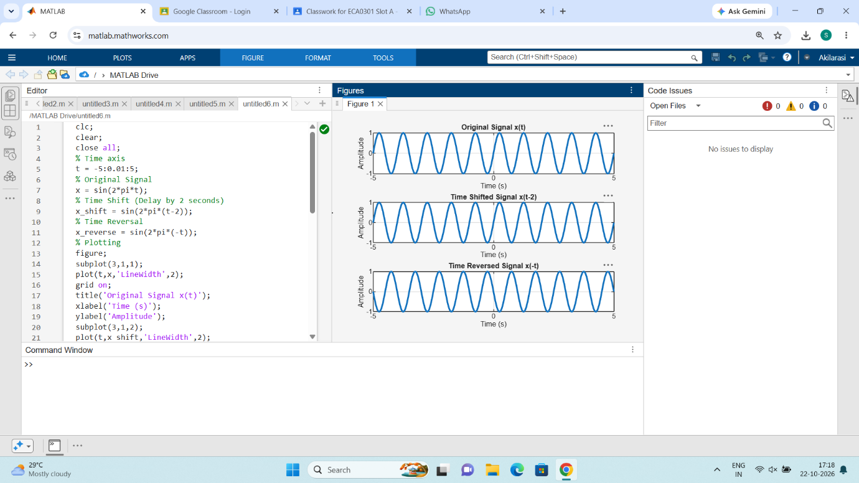

Result
The sinusoidal signal was successfully subjected to time shifting and time reversal using
MATLAB. The time-shifted signal was delayed by 2 seconds, while the time-reversed signal
was obtained by reflecting the original signal about the vertical axis, demonstrating
fundamental signal transformation operations.

